6A^{th} Grade: Unit 8, Lesson 4

- What shape is the shaded face of the rectangular prism shown?
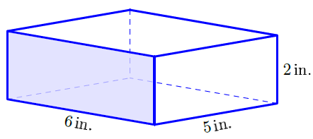
Rectangle

- How many faces does the rectangular prism shown have?
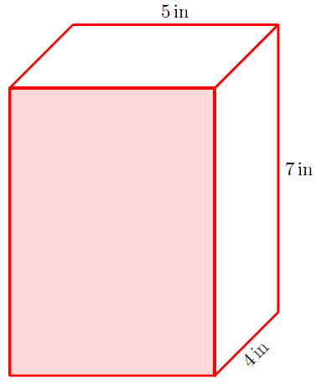
6

- Determine the number of faces the triangular prism shown has.
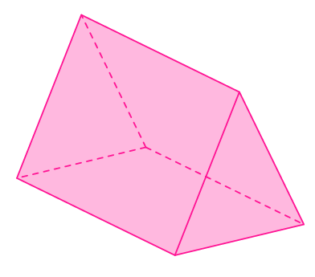
5

